EXPT NO: 4 | TRANSFER LEARNING USING PRE-TRAINED VISION MODELS FOR IMAGE RECOGNITION
DATE:

PRE-LAB QUESTIONS (PROVIDE BRIEF ANSWERS TO THE FOLLOWING QUESTIONS)
- What is transfer learning in deep learning?
Transfer learning is a technique where a pre-trained model's learned knowledge is reused for a new related task. Instead of training a model completely from scratch, we adapt an existing model to the new dataset.

- What are the advantages of using pre-trained models over training from scratch?
- Requires less training time.
- Requires less computational power.
- Can work well with smaller datasets.
- Usually converges faster.
- Already contains useful, learned features.
- Can achieve good accuracy with fewer epochs.

- What is the role of fine-tuning in transfer learning?
Fine-tuning adapts a pre-trained model to the new dataset by allowing selected pre-trained layers to update their weights during training.

- Name any three popular pre-trained computer vision models.
- ResNet
- AlexNet
- VGG

- What is the purpose of Hugging Face and how is it useful in deep learning?
Hugging Face provides access to many pre-trained AI models, datasets, and tools. It simplifies loading and experimenting with pre-trained vision and other machine-learning models.

AIM
To implement transfer learning using pre-trained vision models for image recognition and evaluate their performance on real-world image datasets.

SOFTWARE REQUIREMENTS
- Python
- TensorFlow/Keras or PyTorch
- Google Colab
- Hugging Face Transformers
- Kaggle Dataset
- Matplotlib
- GitHub

OBJECTIVES
Students will be able to:
- Understand the concept of transfer learning.
- Apply pre-trained vision models for image recognition.
- Fine-tune models such as ResNet or AlexNet.
- Utilize Kaggle datasets and Hugging Face vision models.
- Compare transfer learning performance with custom CNN models.

PROCEDURE
PART A: DATASET PREPARATION
Perform the following tasks:
- Download an image dataset from Kaggle.
- Load and preprocess the images.
- Split the dataset into training, validation, and testing sets.

PART B: IMPLEMENTING TRANSFER LEARNING
Load a pre-trained model such as:
- ResNet-50
- AlexNet
Replace the final classification layer according to the dataset classes.
Freeze the feature extraction layers.
Compile the model.

PART C: MODEL TRAINING AND PERFORMANCE EVALUATION
Train the transfer learning model.
Record:
- Training accuracy
- Validation accuracy
- Training loss
- Validation loss
- Test accuracy
Visualize:
- Accuracy vs Epoch
- Loss vs Epoch

PART D: USING HUGGING FACE PRE-TRAINED MODELS
Perform the following tasks:
- Load a pre-trained vision model from Hugging Face.
- Perform image classification on sample images.
- Compare predictions with the transfer learning model.
- Document observations and upload the notebook to GitHub.

(CODE: CONATAINS STUDENT ROLL NOS
SCREENSHOT OF CODE
SCREENSHOT OF OUTPUT)
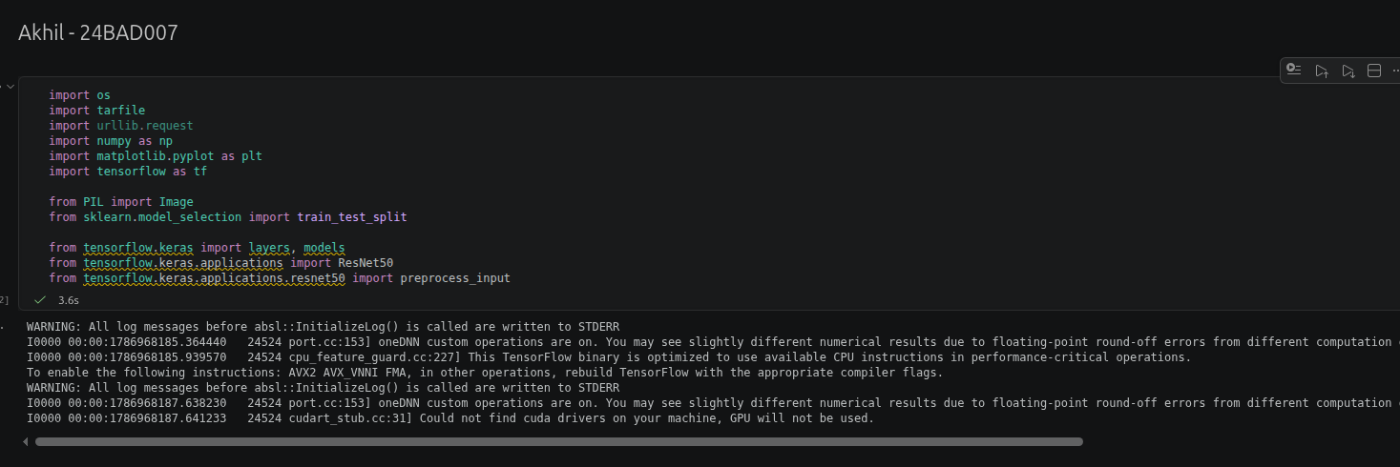

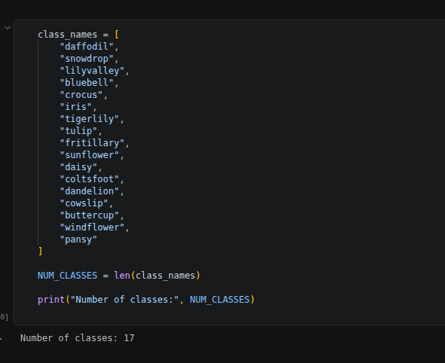
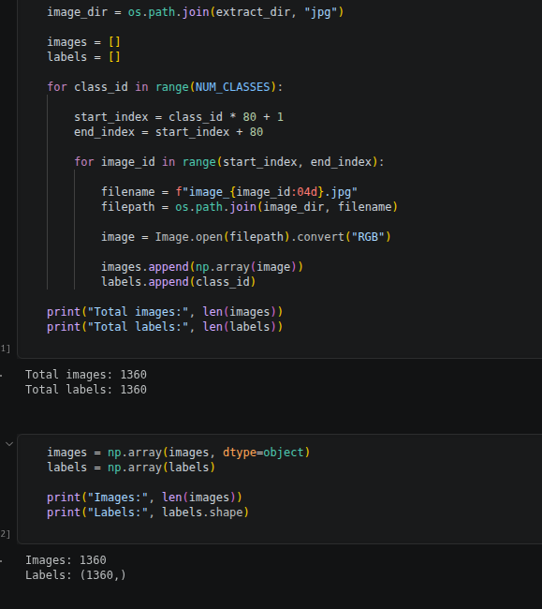
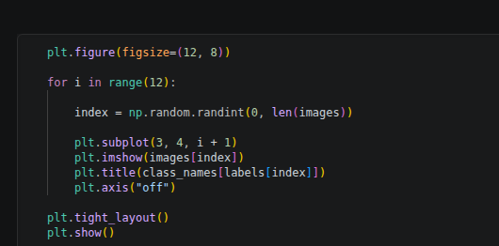

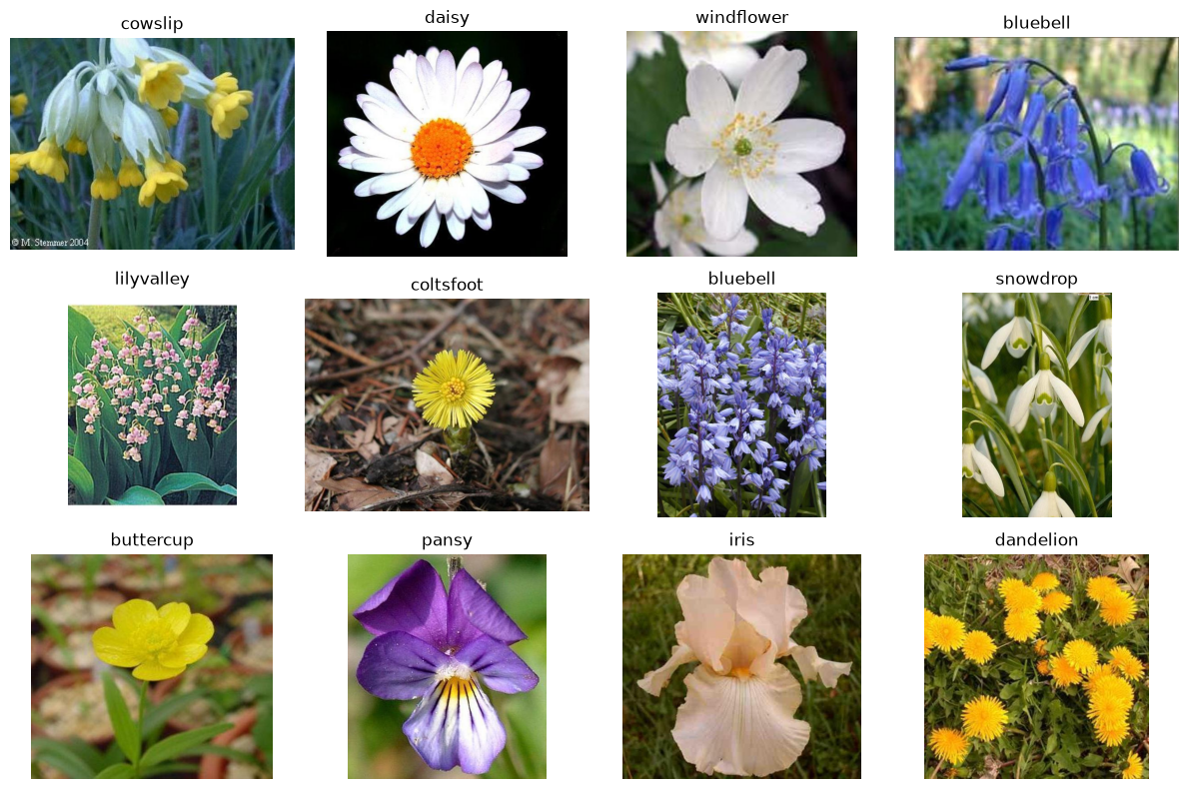
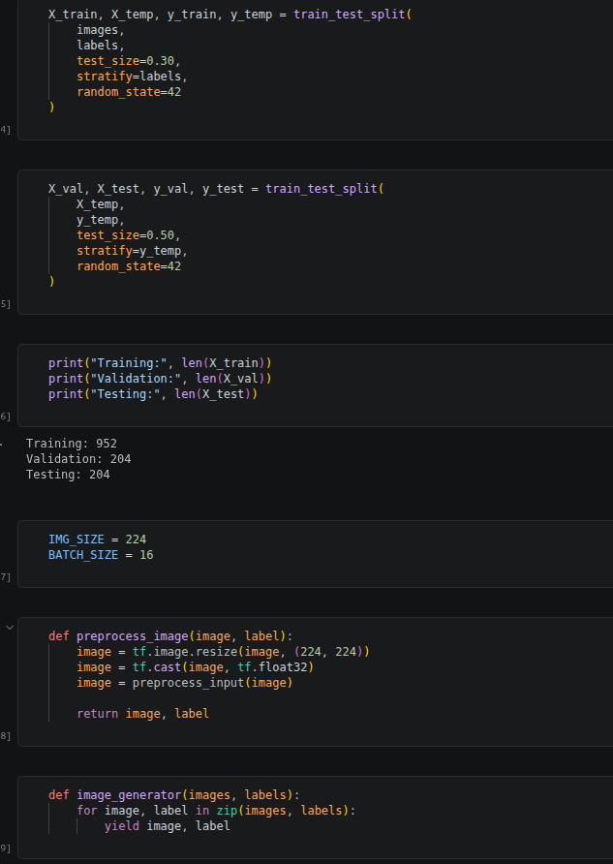

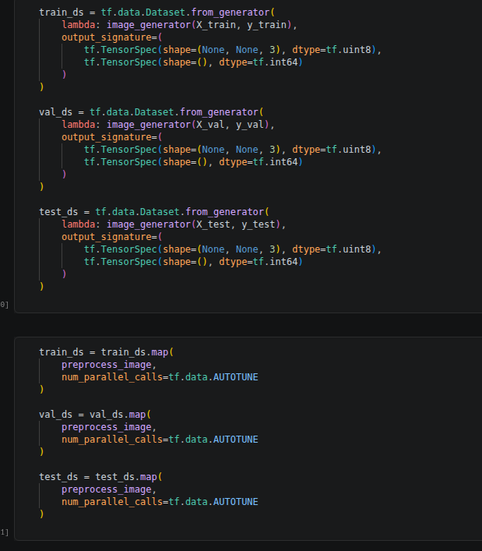
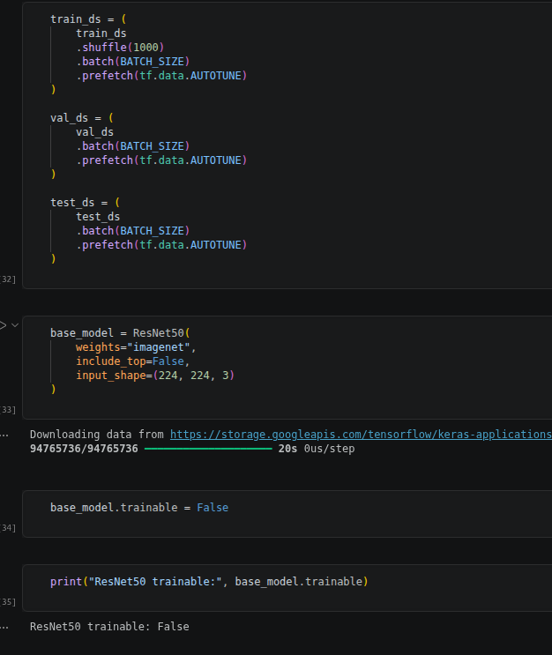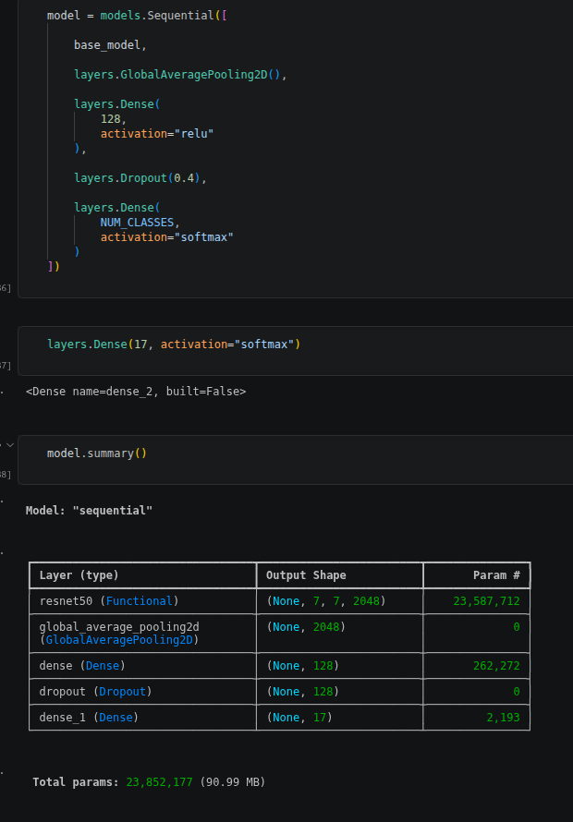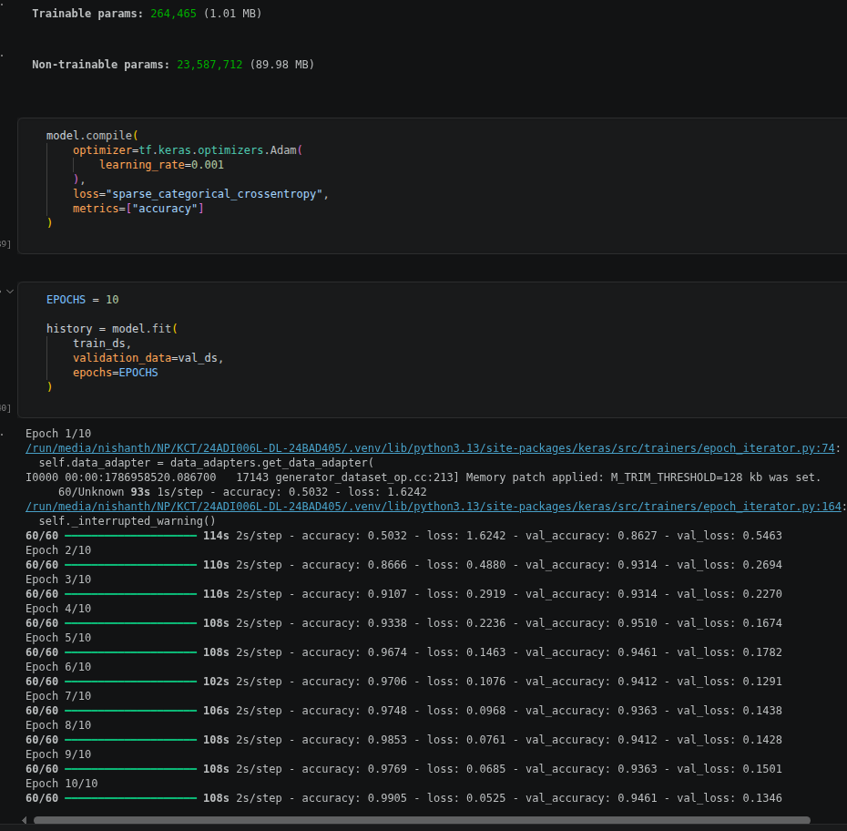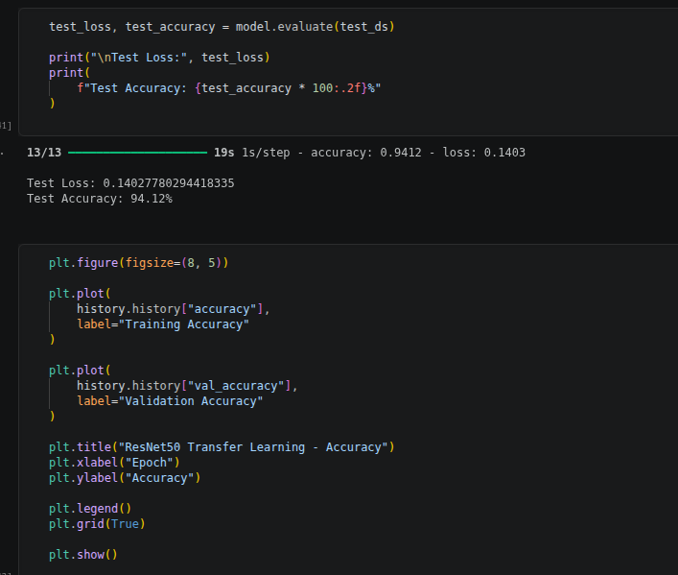
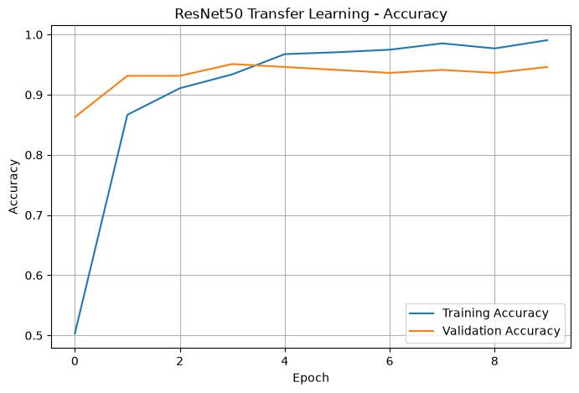
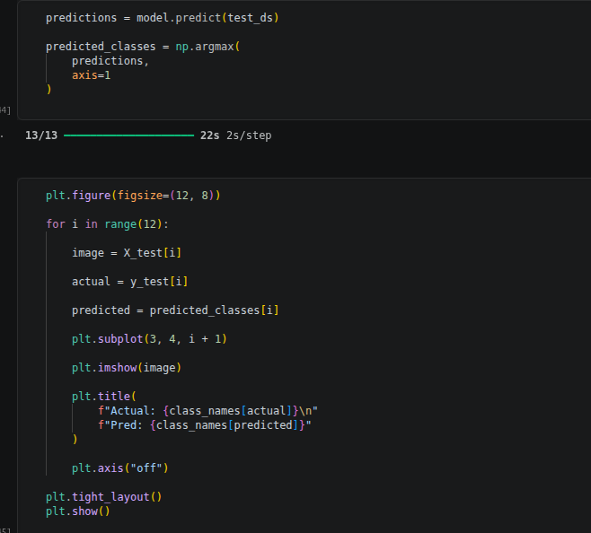
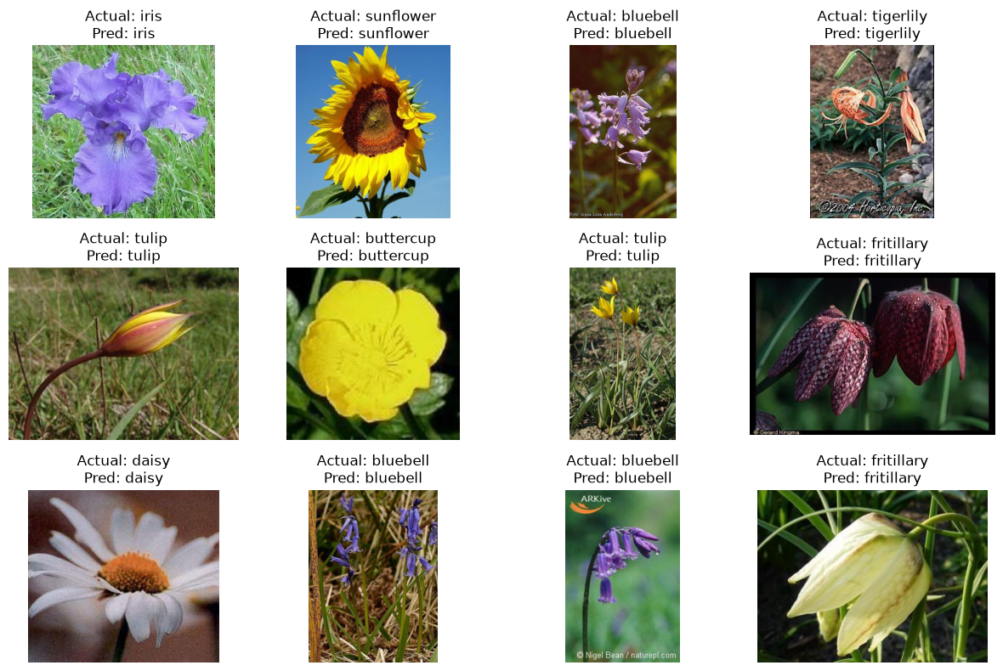
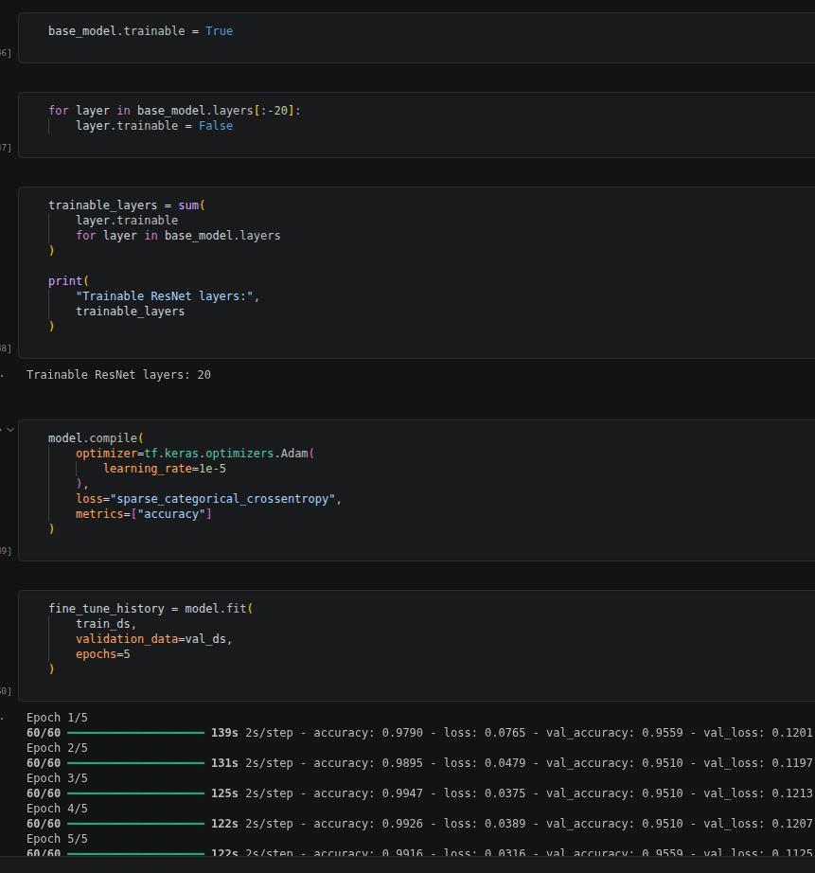

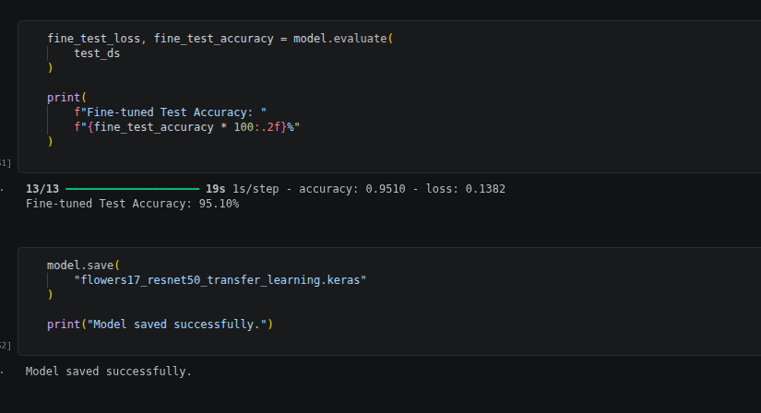
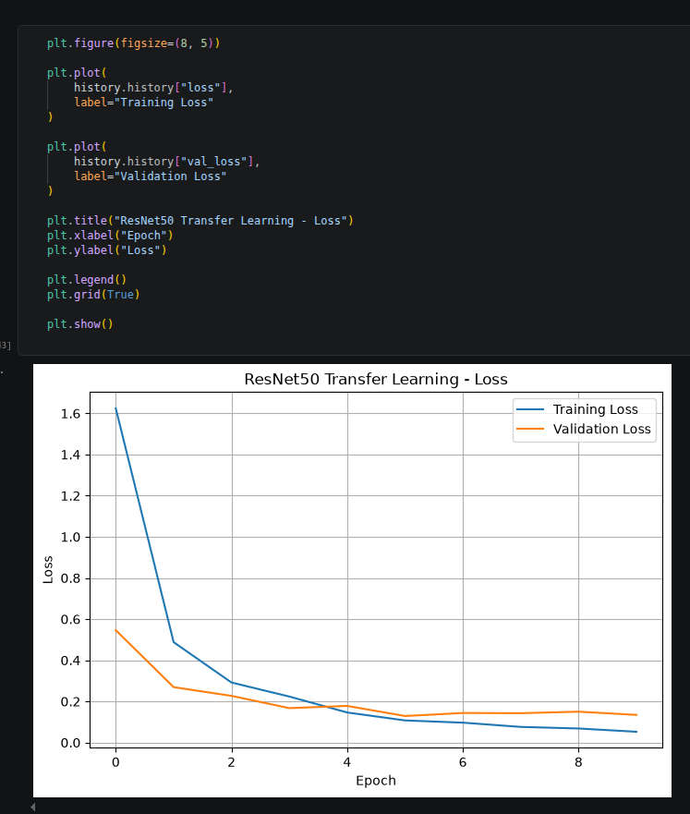

EXPECTED OUTCOME
Students will understand the advantages of transfer learning and gain practical experience in fine-tuning pre-trained vision models from TensorFlow/PyTorch and Hugging Face for image recognition tasks.

POST-LAB QUESTIONS (PROVIDE BRIEF ANSWERS TO THE FOLLOWING QUESTIONS)
- What are the advantages of transfer learning compared to training a CNN from scratch?
Transfer learning requires less training time, less computational resources, and usually less training data. Since the pre-trained model already learned useful visual features, it can achieve good performance faster than a CNN trained from scratch.

- Why are pre-trained models able to achieve higher accuracy with fewer training epochs?
Pre-trained models have already learned useful features such as edges, textures, shapes, and patterns from large datasets. Therefore, they do not need to learn these basic features again and can focus on adapting to the new classification task.

- Compare the performance of the transfer learning model with the CNN implemented in the previous experiment.
 | Custom CNN | Transfer Learning
Training time | Higher | Lower
Data required | More | Less
Covergence | Slower | Faster
Accuracy | Varies | Often higher
Feature learning | From scratch | Pre-trained

- What is the purpose of freezing layers during transfer learning?
Freezing layers prevents their weights from being updated during training. This preserves the useful features learned from the original dataset while allowing the new classification layer to learn the new task.

- How can Hugging Face simplify the deployment and experimentation of vision models?
Hugging Face provides ready-to-use pre-trained models, processors, datasets, and libraries. This makes it easier to load models, perform image classification, test predictions, and experiment without implementing the complete architecture from scratch.

ASSESSMENT
Description | Max Marks | Marks Awarded
Pre Lab Exercise | 5
In Lab Exercise | 10
Post Lab Exercise | 5
Viva | 10
Total | 30
Faculty Signature

